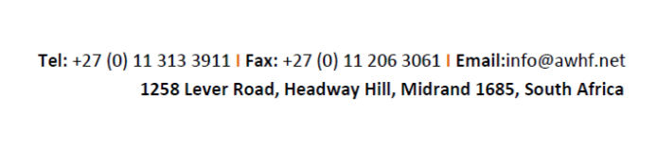

**AWHF Professional Immersion Fellowship**

**Deadline for submission:30 January 2022**

**APPLICATION FORM**

|  |  |  |  |  |
| --- | --- | --- | --- | --- |
| **A- Identity of applicant** | | | | |
| **Surname:** | | | **Other name(s):** | |
| **Sex: Male □ Female □** | **Age:** | | **Nationality:** | |
| **Passport Number:** | **World Heritage Site Name:** | | | |
| **Country of Residence:** |  | | | |
| **Physical Address: [please state country]** | | | | |
| **Telephone:**  **WhatsApp Number:** | | **Email (*):** | | |
| **B- Academic Background:** | | | | |
| **Discipline:** | | | | |
| **Academic/ Professional Qualifications:** | | | | |
| **C- Professional Background** | | | | |
| **Field(s) of expertise of the applicant:** | | | | |
| **Work/ Professional Experience:** | | | | |
| **Briefly describe your work/professional experience relevant to the project (maximum 100 words):** | | | | |
| **B- Institutional affiliation** | | | | |
| **Name of institution:** | | | | |
| **Address of institution:** | | | | |
| Telephone: | Email: | | | Website: |
| **Head of institution** | | | | |
| Surname | | Other name(s) | | |
| Telephone: | | Email (*): | | |
| I, the undersigned ………………………..……………….., head of the applicant’s organisation, accept to release the applicant for the implementation of the project in the case the application to the fellowship programme is successful (**).  Name:  Position/Institution:  Signature/Stamp: | | | | |
| **C- Description of the project (maximum 400 words)** | | | | |
| 1. Title of the project: 2. Heritage site(s) concerned: 3. Issues identified: 4. Expected outcomes: 5. Implementation strategy: 6. Planning of activities (***): 7. Provisional budget and distribution including additional funds expected (***): 8. Other institutions supporting the project: | | | | |
| **D- Confirmation from the project beneficiary (e.g. site/administrative manager/national department head)** | | | | |
| I, the undersigned ………………………..……………….., head of the World Heritage Site where the applicants Professional Immersion Fellowship project will take place, accept, support and acknowledge that the applicant is applying for funding to implement the Professional Immersion Fellowship project at the World Heritage Site that I am in charge of. I confirm that the information provided above is true, complete and correct to the best of my knowledge **(**)**.  Name:  Position/Institution:  Signature/Stamp: | | | | |
| **E- Certification by the applicant** | | | | |
| I, the undersigned, certify that the information above is true, complete and correct to the best of my knowledge.  Date: Signature | | | | |
| The complete application package (letter of motivation, letters of support, curriculum vitae, completed application form and official bank letter with banking details and bank stamp) should be sent by **30 January 2022** via email to: [AWHFProfessionalFellowship@gmail.com](mailto:AWHFProfessionalFellowship@gmail.com) with copy to [info@awhf.net](mailto:info@awhf.net).   |  | | --- | |  | |  |  | | | | | |

(*) Mandatory

(**) Preferably to be supported by an official letter on letterhead and signed by the relevant authority.

(***) This section may be put on a separate page.